Procedure to update the charts after the interval of the report data source is changed
- Start the PecChart. The chart is displayed as below.
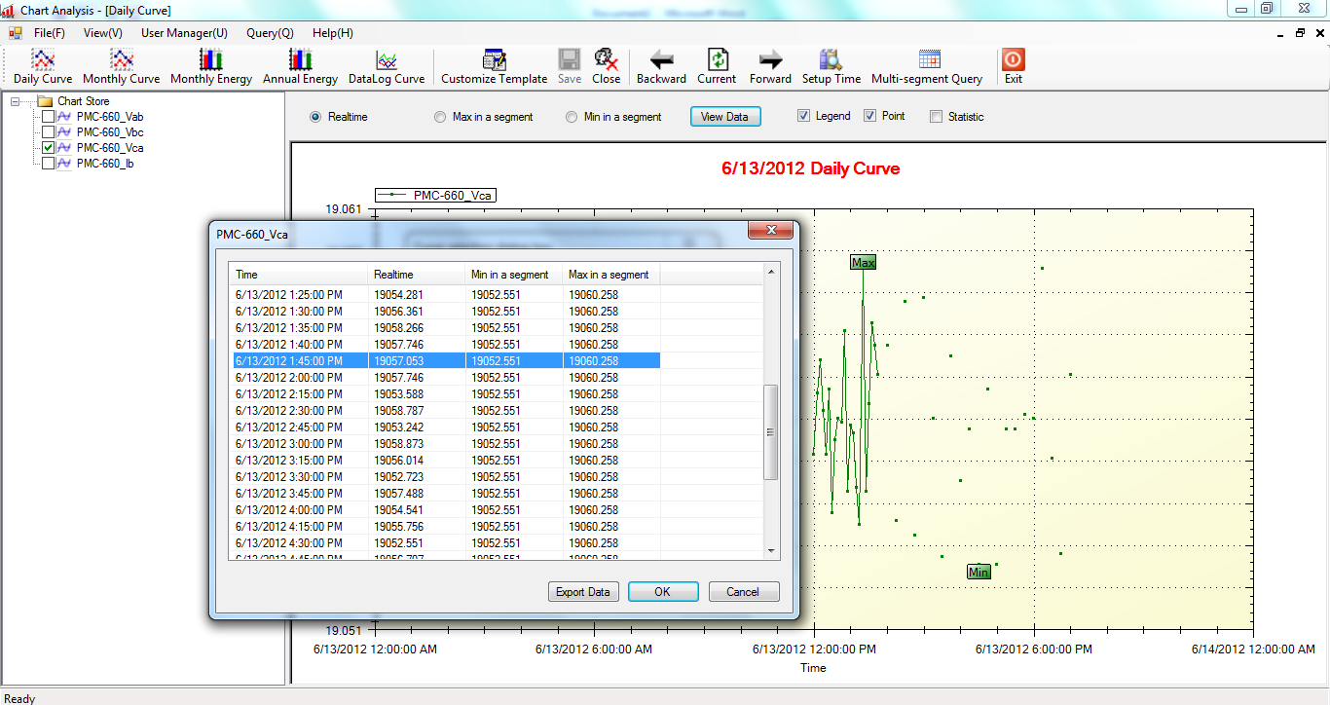
- Restart the PecSCADA.
- In PecChart, right-click on the chart name, select Modify Source(X).
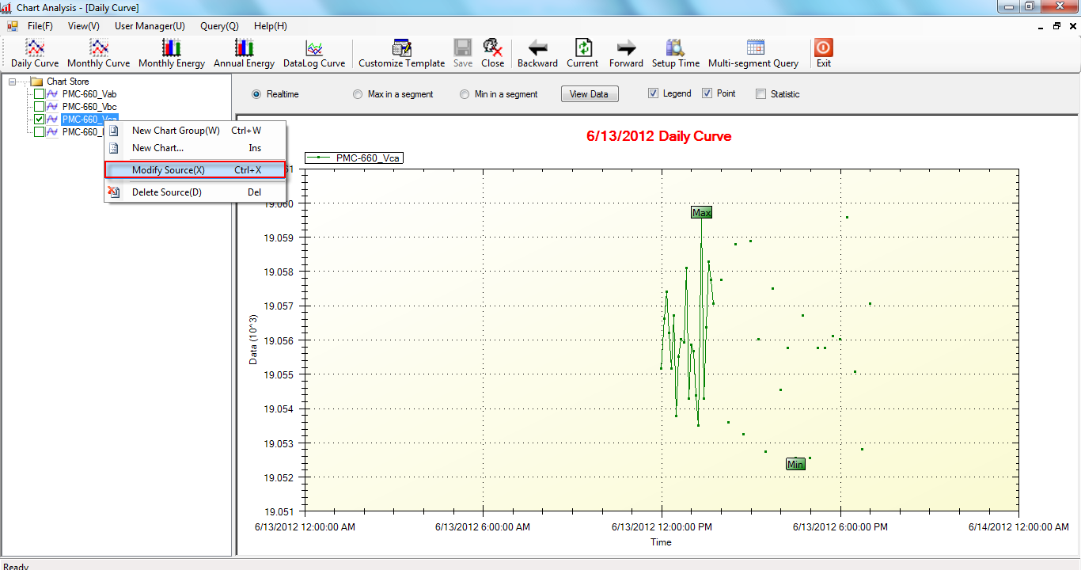
- Click on the source and click OK. Thus the source is reselected.
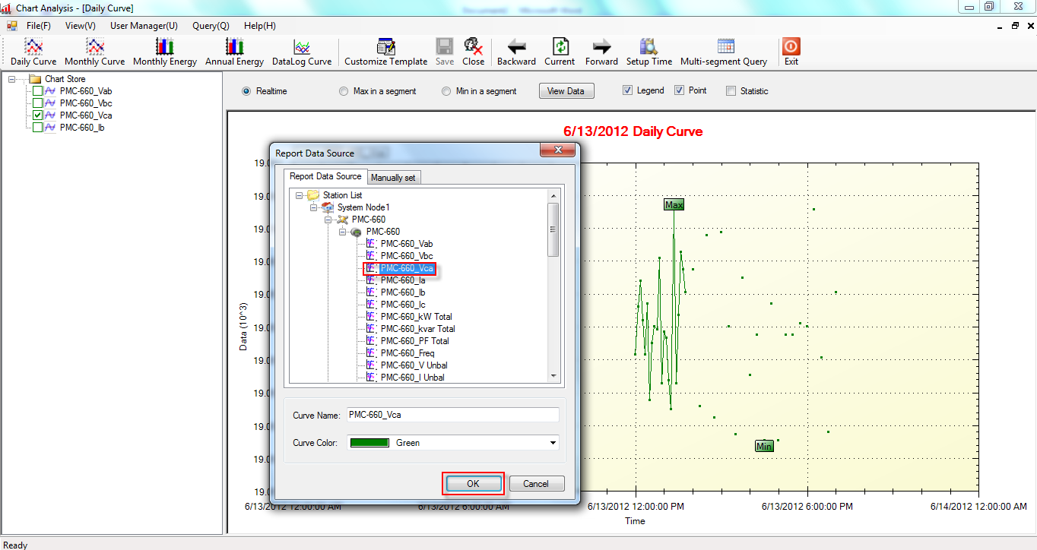
- The chart is refreshed, all sample data is drawn in line.
